**Case for Copyright Infringement**  
  
By: Matthew Kurtz  
For: CS383 – Software Engineering – Dr. BC

**Item in Question:**  
  
A “Portal” from Portal 2

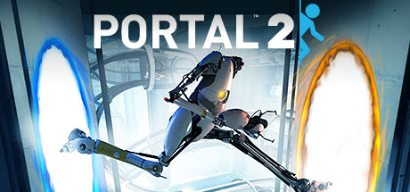

**Overview:**

The “Portal” is a central gameplay mechanic in the video game "Portal 2," developed by Valve Corporation. It allows players to create inter-spatial portals on flat surfaces, enabling them to teleport objects and themselves between two points within the game environment.

**Claim:**

Valve Corporation could potentially claim copyright infringement if they believe that my use of the Portal mechanic in our Unity game constitutes unauthorized use of their copyrighted material. This claim would be based on the assertion that the “Portal” mechanic is a unique and creative expression protected under copyright law.

**Rebuttal:**

**Fair Use Defense**: I can argue that my use of the Portal mechanic falls under the fair use doctrine. For example, I could say it’s use is “transformative” and it differs from what the mechanic does in Portal 2. Since I’m using it to switch levels, I’d consider it “transformative”.

**Lack of Substantial Similarity**: I can contend that while our game may feature a similar gameplay mechanic to the Portal, it differs significantly in its implementation, context, and overall expression. For example, as mentioned in the Fair Use Defense rebuttal, my implementation differs from what Portal 2 uses it for. Also, since we have a different storyline, that differs from its original use.

**Generic Elements**: I can argue that the Portal mechanic itself contains elements that are generic or commonly used in the gaming industry and therefore not protectable under copyright law. For instance, the concept of teleportation or creating portals between two points is a widely used gameplay mechanic in various video games, predating the release of Portal 2.

**Image of Element used in Hot-Dog Jones:**

